Revise topic

Data types

Variable  
Heap me  
JVM JDK,JRE

First program:

OOP’S concept:

Class object

Pen color

Gel ball

Blueprint

10 blue pen

10 green pen

Constructor

One method

-ComapildeafaultPen()

-same name as class

-return type

-object create that constructor will call

Student

Name,dept,loc

Constr grade

Print_Info

Employee(name,sal,loc,id)

Polymo

Compile-time polymori run-time poly

Method overloading Method Overriding

Inhert

Employee

Print(name,id)

Print(id,sal)

Print(name,desg)

Method overloading

-chang no of argu

-cha

ng data type of parameters

Activa (Hero)

Activa+(add feat.)

Activa ++(new)

IS-A (pareant –child)

-retrun type

Mehod overriding

Inheritance

1)single level

2)Multilevel

3) Hierarchical Inheritance

4)Multiple

5)Hybrid

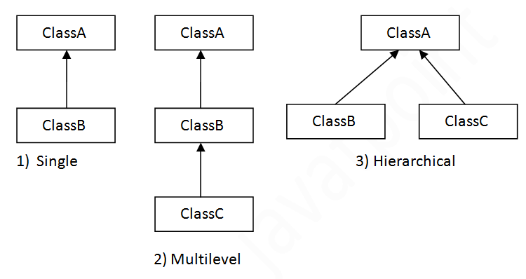

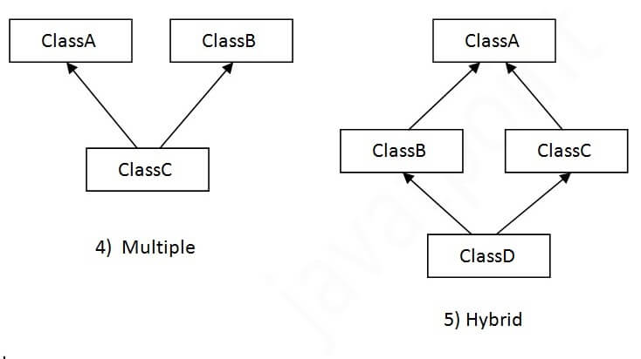

Super

Keyword ref.variable(immed. Par object refer)

1)instance variable

2)method

3)constru

* * * *  
* *  
* *  
* *  
* * * *

1  
2 2  
3 3 3  
4 4 4 4  
5 5 5 5 5

Access modifiers

Public:-anywhere   
private:- password (within class)  
protected:-inherit

Within package

Package apply inheritance(outside package)

(child class)(outside package)  
default:-within package (outside package not accessable)

Protected String msg=””

Encapsulation:-

Wrapping up of data and functions/methods in single unit

Java Bean

Class Student{

Private String password;//data hide

Public String name;

Protected String email_id;

String city;

Public void info(){

Sys()

}

}

Abstraction

1)Abstract class(

Abstract class Student{

1)abstract method

2)non-abstract method

3)constructor)

4)Student object cant create

2)interface(100% abstac)

Abstract,  
public abstract  
no constrctor

(imple multiple)

Acessmod,packages,

1)Areaprivate double pi=3.14;

(circle,reactangle)

2)Person(private int age <=24)elgible

Abstraction:-

Hide implementation showing only the functionalty

1)Abstract class(0 to 100%)

2)interface(100%)

1)Abstract class

-abstract class decl start with abstract

Abstract class Student{}

-abstract and non- abstract

Abstract void info()

-cannot insitanisite the class(object)

-constrctor allowed

-static methods

-final methods which which will force the subclass

Abstract Shape(area(),con,msg)  
inherit circle(cal)

Interface

Method declar